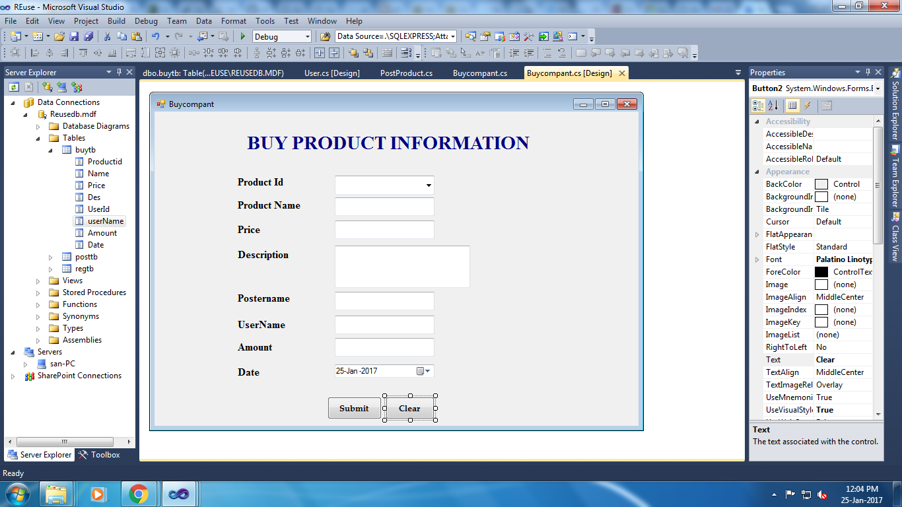

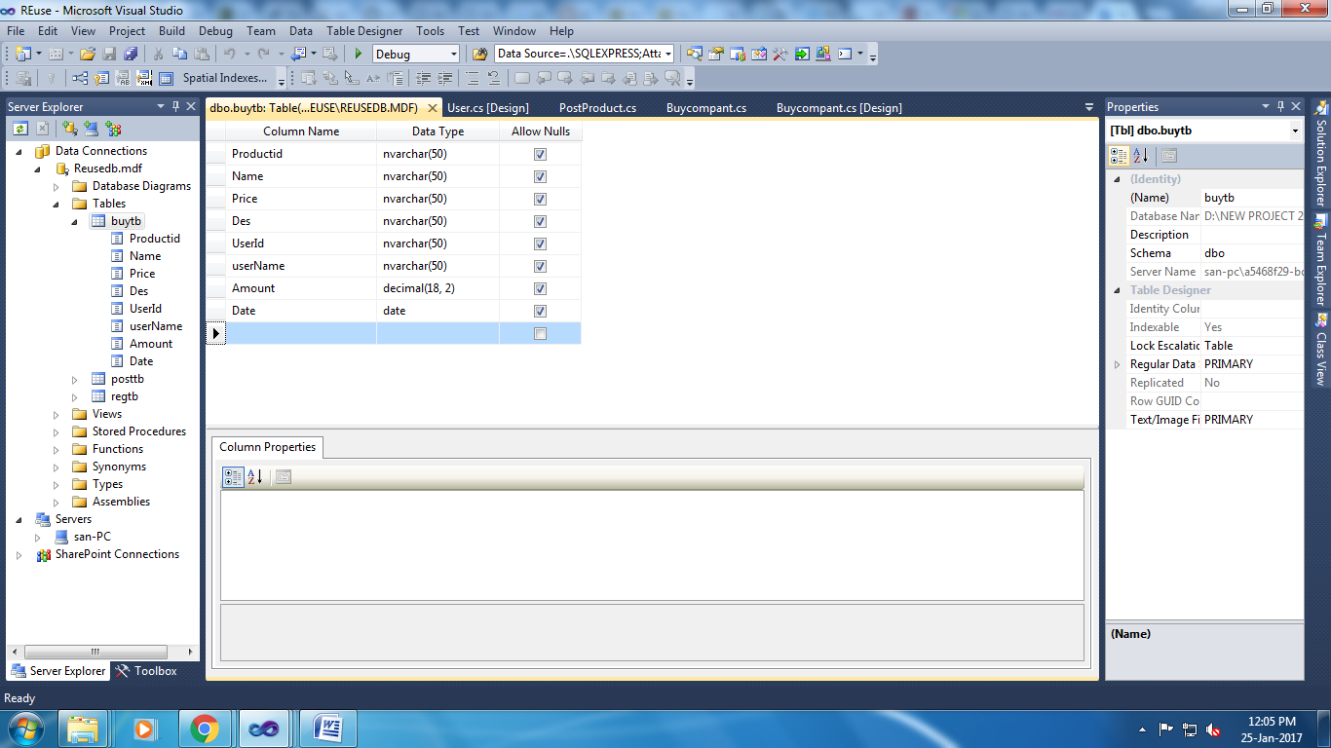

using System;

using System.Collections.Generic;

using System.ComponentModel;

using System.Data;

using System.Drawing;

using System.Linq;

using System.Text;

using System.Windows.Forms;

using System.Data;

using System.Data.SqlClient;

namespace REuse

{

public partial class Buycompant : Form

{

SqlConnection con = new SqlConnection(@"Data Source=.\SQLEXPRESS;AttachDbFilename=D:\New Project 2016\BishopUgProject\REuse\REuse\Reusedb.mdf;Integrated Security=True;User Instance=True");

SqlCommand cmd;

public Buycompant()

{

InitializeComponent();

}

private void comboBox2_Enter(object sender, EventArgs e)

{

}

private void Button1_Click(object sender, EventArgs e)

{

cmd = new SqlCommand("insert into buytb values('" + comboBox1.Text + "','" + TextBox1.Text + "','" + TextBox2.Text + "','" + textBox3.Text + "','" + textBox4.Text + "','" + textBox5.Text + "','" + textBox6.Text + "','" + dateTimePicker1.Text + "')", con);

con.Open();

cmd.ExecuteNonQuery();

con.Close();

MessageBox.Show("Record Saved!");

}

private void Button2_Click(object sender, EventArgs e)

{

TextBox1.Text = "";

TextBox2.Text = "";

textBox3.Text = "";

textBox4.Text = "";

textBox5.Text = "";

textBox6.Text = "";

}

private void comboBox1_Enter(object sender, EventArgs e)

{

comboBox1.Items.Clear();

con.Open();

cmd = new SqlCommand("select * from posttb", con);

SqlDataReader dr = cmd.ExecuteReader();

while (dr.Read())

{

comboBox1.Items.Add(dr["Productid"].ToString());

}

con.Close();

}

private void comboBox1_SelectedIndexChanged(object sender, EventArgs e)

{

con.Open();

cmd = new SqlCommand("select * from posttb where Productid='" + comboBox1.Text + "'", con);

SqlDataReader dr = cmd.ExecuteReader();

if (dr.Read())

{

TextBox1.Text = dr["ProductName"].ToString();

TextBox2.Text = dr["Price"].ToString();

textBox3.Text = dr["Description"].ToString();

textBox4.Text = dr["UserId"].ToString();

}

con.Close();

}

}

}